22BCE3799

Apurba Koirala

Cryptography and Network Security Lab Assessment 5

RC4 operations: The same example as class is taken and 8 is used instead of 256

1. Permutation of the S array

Code:

#include <iostream>

#include <vector>

using namespace std;

void printS(const vector<int>& S) {

for (int val : S) {

cout << val << " ";

}

cout << endl;

}

void rc4_permutation(vector<int>& S, const vector<int>& T) {

int j = 0;

for (int i = 0; i < 8; i++) {

j = (j + S[i] + T[i]) % 8;

swap(S[i], S[j]);

cout << "Iteration " << i << ": ";

printS(S);

}

}

int main() {

//in this program, we are running the RC4 algorithm to 8 bits, as taking 256 bits would be very difficult to assess, same as class

int keysize;

cout<<"Enter Key size: \n";

cin>>keysize;

if (keysize < 1 || keysize > 8) {

cout << "Invalid key size. Must be between 1 and 8.\n";

return 1;

}

vector<int> S(8), T(8), key(keysize);

cout<<"Enter Key:\n";

for (int i = 0; i < keysize; i++){

cin>>key[i];

}

for (int i = 0; i < 8; i++) {

S[i] = i;

T[i] = key[i % keysize];

}

rc4_permutation(S, T);

cout << "S after permutation:\n";

for (int i = 0; i < 8; i++) {

cout << S[i] << " ";

}

cout << endl;

return 0;

}

Output:

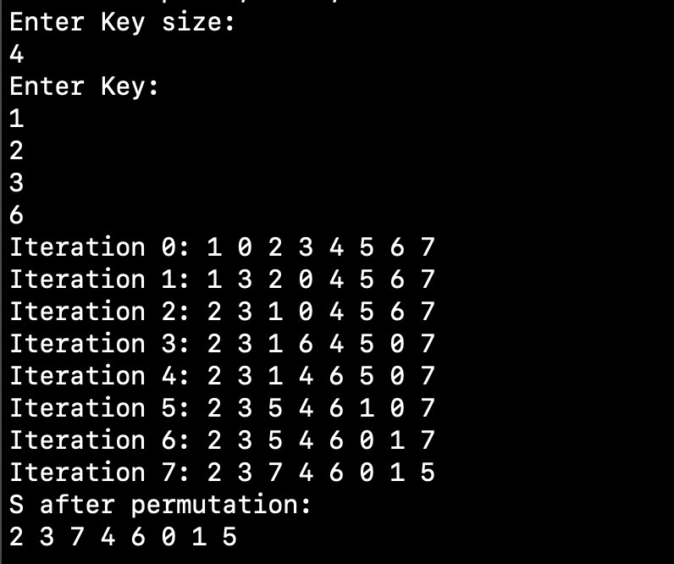

1. Stream Generation

#include <iostream>

#include <vector>

using namespace std;

void printS(const vector<int>& S) {

for (int val : S) {

cout << val << " ";

}

cout << endl;

}

void rc4_keystream(vector<int>& S, int numBytes) {

int i = 0, j = 0;

cout << "Generated Keystream:\n";

for (int count = 0; count < numBytes; count++) {

i = (i + 1) % 8;

j = (j + S[i]) % 8;

swap(S[i], S[j]);

int t = (S[i] + S[j]) % 8;

int k = S[t];

cout << k << " ";

}

cout << endl;

}

int main() {

vector<int> S(8);

cout<<"Enter S vector: \n";

for (int i = 0; i<8; i++){

cin>>S[i];

}

cout << "Initial S: ";

printS(S);

int numBytes;

cout << "Enter number of keys to generate: ";

cin >> numBytes;

rc4_keystream(S, numBytes);

return 0;

}

1. Encryption

Code:

#include <iostream>

#include <vector>

using namespace std;

void printVector(const vector<int>& vec) {

for (int val : vec) {

cout << val << " ";

}

cout << endl;

}

vector<int> rc4_encrypt(vector<int>& plaintext, vector<int>& keystream) {

vector<int> ciphertext;

for (size_t i = 0; i < plaintext.size(); i++) {

ciphertext.push_back(plaintext[i] ^ keystream[i]);

}

return ciphertext;

}

int main() {

int plaintextSize;

cout << "Enter plaintext size: \n";

cin >> plaintextSize;

vector<int> PT(plaintextSize), K(plaintextSize);

cout<< "Enter plaintext: \n";

for (int i = 0; i< plaintextSize; i++){

cin>> PT[i];

}

cout<< "Input Generated Keystream: \n";

for (int i = 0; i< plaintextSize; i++){

cin>> K[i];

}

vector<int> CT = rc4_encrypt(PT, K);

cout << "Ciphertext: ";

printVector(CT);

return 0;

}

Output:

